OMICROM Input Response
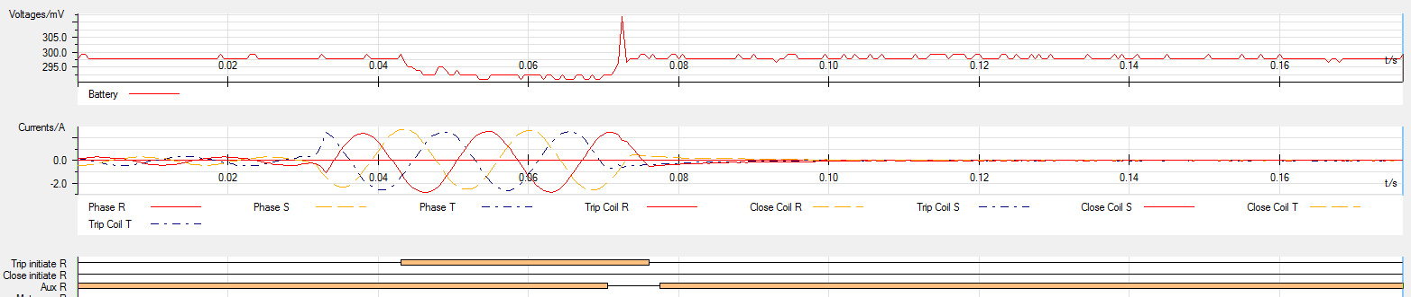
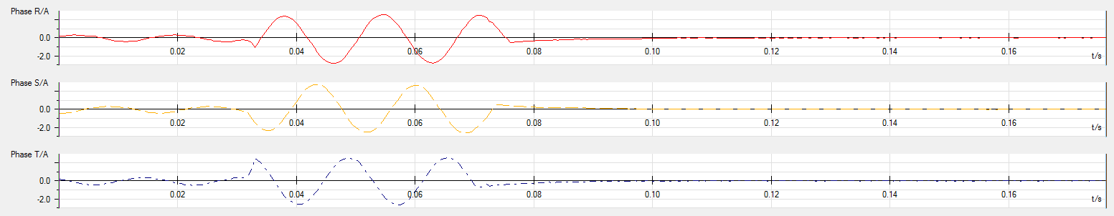
BCM Output Response

